A copy of the output from the end of the module Create a web API with ASP.NET Core controllers:
using ContosoPizza.Models;
using ContosoPizza.Services;
using Microsoft.AspNetCore.Mvc;

namespace ContosoPizza.Controllers;

[ApiController]
[Route("[controller]")]
public class PizzaController : ControllerBase
{
public PizzaController()
{
}

// GET all action
[HttpGet]
public ActionResult<List<Pizza>> GetAll() =>
PizzaService.GetAll();

// GET by Id action
[HttpGet("{id}")]
public ActionResult<Pizza> Get(int id)
{
var pizza = PizzaService.Get(id);

if(pizza == null)
return NotFound();

return pizza;
}

// POST action
[HttpPost]
public IActionResult Create(Pizza pizza)
{
PizzaService.Add(pizza);
return CreatedAtAction(nameof(Get), new { id = pizza.Id }, pizza);
}

// PUT action
[HttpPut("{id}")]
public IActionResult Update(int id, Pizza pizza)
{
if (id != pizza.Id)
return BadRequest();

var existingPizza = PizzaService.Get(id);
if(existingPizza is null)
return NotFound();

PizzaService.Update(pizza);

return NoContent();
}
// DELETE action
[HttpDelete("{id}")]
public IActionResult Delete(int id)
{
var pizza = PizzaService.Get(id);

if (pizza is null)
return NotFound();

PizzaService.Delete(id);

return NoContent();
}
}

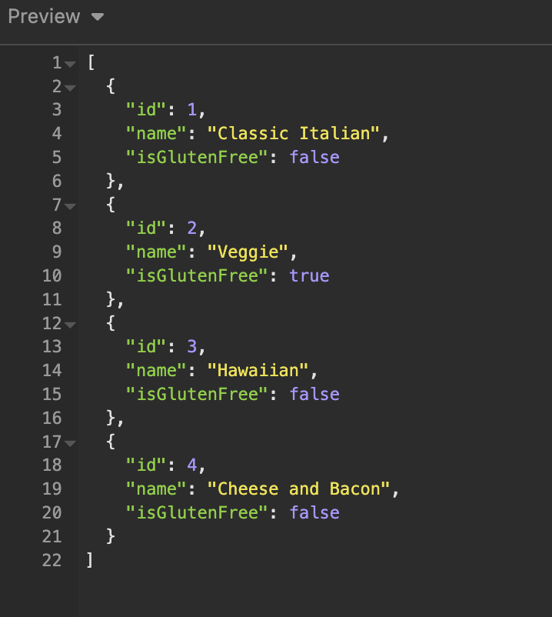
Im using the software insomnia to test the endpoints:
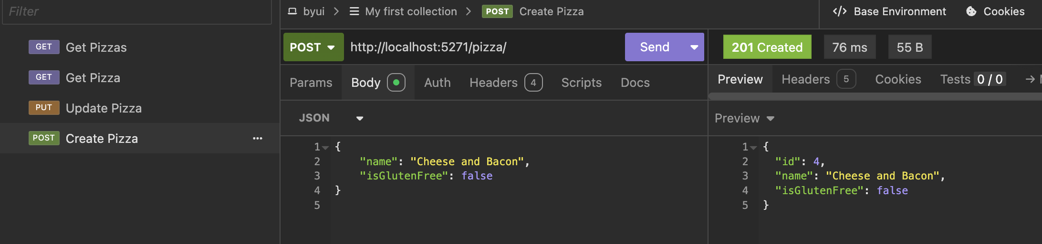

A text copy of working sales summary function for Part 2:

static void getSummary(double salesTotal, IEnumerable<string> salesFiles)
{
var report = new System.Text.StringBuilder();
report.AppendLine("Sales Summary");
report.AppendLine("----------------------------");
report.AppendLine($"Total Sales: {salesTotal:C}");
report.AppendLine();
report.AppendLine("Details:");

foreach (var file in salesFiles)
{
if (Path.GetFileName(file) == "sales.json")
{
var salesJson = File.ReadAllText(file);
SalesData? data = JsonConvert.DeserializeObject<SalesData?>(salesJson);
var folderName = Directory.GetParent(file)?.Name;
report.AppendLine($" Folder: {folderName} | {Path.GetFileName(file)}: {(data?.Total ?? 0):C}");
}
}

File.WriteAllText(
Path.Combine(Directory.GetCurrentDirectory(), "salesTotalDir", "sales_summary.txt"),
report.ToString());
}

getSummary(salesTotal, salesFiles);

